SNAKE
Design Brief

Overview:
‘Snake’ has the player control a snake that grows in length as food is collected. Food will spawn at random locations on the screen for the player to collect, increasing the snake’s length and the player’s score.
The player must avoid colliding with the walls (defined by the screen edge) and avoid colliding with the snake’s body.

The program will be written in C++, using VisualStudio.

Basic Class Diagram:

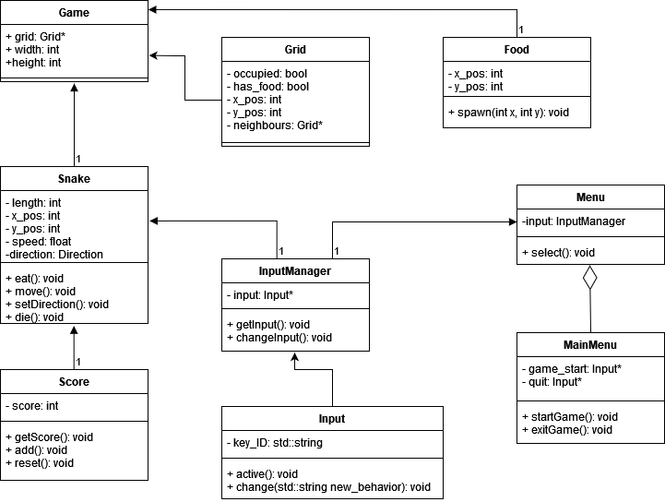

Game State
The following scenes will be in the project
• Game
• MainMenu
MainMenu is loaded at startup, with the option to either run the game or quit. An option to add a settings menu can be implemented here too.
Game will load the player, spawn the food at random locations, and display the player's current score.
Score and length will increase with food collision.
Game Over will occur with any collision that is not food.
Game Over will return the player to the MainMenu.

Player
Snake:
The snake will use the following data:
Vector2 position; sets the sprite's position on screen
Vector2 speed; sets the sprite's movement speed
Texture2D texture; sets the sprite's .png asset.
The snake data structure is similar to a single-linked list. The snake head is the linked-list
tail and the snake tail is the linked-list head. The figure below shows how the snake segments, by
being associated with a particular row and column on the grid, model a snake. Each segment has a next
pointer which points in the direction the segments move. These next pointers allow the head and tail of
the snake to be advanced easily.
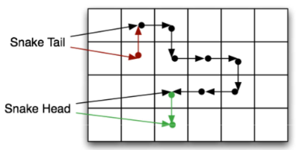
Red nodes and pointers represent the state of the snake before the tail moves.
Green nodes and pointers represent the new state of the snake after the head moves

Controller:
The player control's will be called in InputManager.
W,A,S,D keys will be used to set the player's direction of movement.

Collision:
Position checks will be made in Game.
Checks will determine if the player's position is:
greater than the screenWidth or screenHeight.
equal to a currently occupied position.
An occupied position can include food or player.

Snake Length:
The snake length will increase by an additional sprite when the player collides with food.
The snake length will use the player's previous position data in order to form the trail and prevent collision when adding the new sprite.

Food
Food will be using the following data:
Vector2 spawn; sets the sprite's position on screen
bool active; used as a trigger
Texture2D texture; sets the sprite's .png asset.
Active Boolean:
While true, the food will be spawned at a random unoccupied position.
The active state will change when collision with the player occurs.
Upon player collision, the food state will become false which triggers the snake length and score to increase.
Afterwards, the state will become true which will set a new on screen position for the food.

Grid
The grid, using a Vector2, will help determine position for all sprites and if the position is occupied or not.

Visual Examples
Main Menu:
The basic aesthetic is rather simple for a wider appeal. The Main menu will display the Play and Exit options using the universally recognised triangular play and square stop button. However, adding text next to the icons could be better. Below displays both potential button styles.

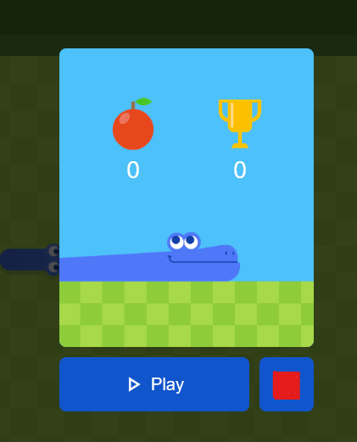
The player's score is represented by the apple with a counter below. A trophy icon could be used instead, or it could also be used to represent a 'High Score' feature if implemented.

Initail Gameplay:
The snake (player) will start rather small with a artistically simple style. The grid and walls will use a similar colour pallet but with enough difference for the player to visually see the wall and the the grid-like playing area. Having the visual grid helps the player to determine the snakes projected path and make adjustments accordingly. The darker, single coloured walls indicate the boundaries.
Current score is represented in the top right using the same apple sprite used in game and for the menu.

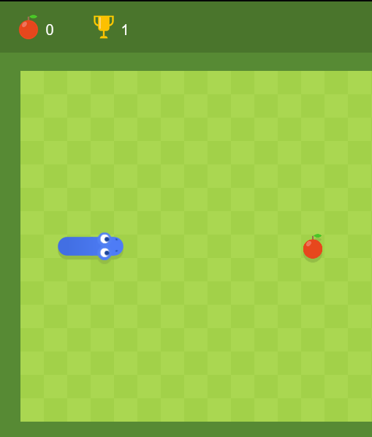

Game Progression:
As the player collects more apples, the snake's length will increase, as will the player's score

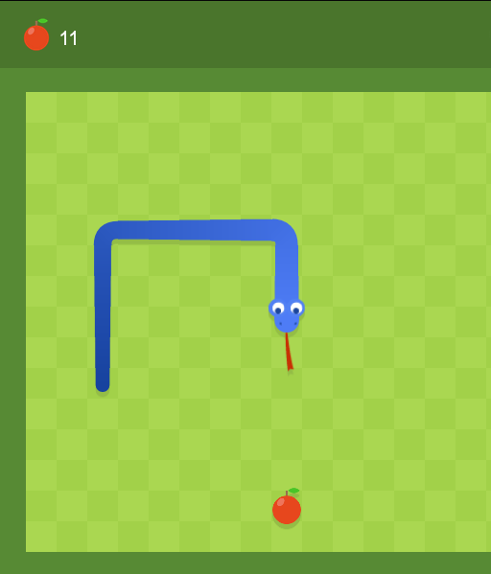
Testing Strategies
Tests should be run throughout the creation process. These will be conducted by running the program after each of the following function implementation. These test will check:
Correct window size
Switching from main menu to game play
Grid and walls are loaded correctly
Sprites are loaded correctly
Controls and movement
(prevent backwards movement into the player)
Collisions with each wall
Return to main menu afterwards
Collision with self
Return to main menu afterwards
Apple spawn
Apple collision;
Apple re-spawn
Score increase
Length increase
After all these functions are tested and implemented the game should be play tested in full with other participants to check for any unseen errors.

